# The Website

**Home Page:**

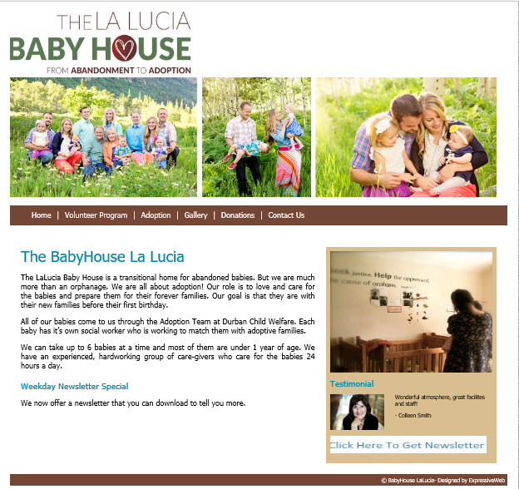

This is the first screen that will be shown to the User. The user will have the option of clicking on one of the tags to go the corresponding page. The user will have the option to Login or Register. The user will be able to download the weekly Newsletter uploaded. The home page will give a brief description of what the Baby House does and is about.

**Volunteer Page:**

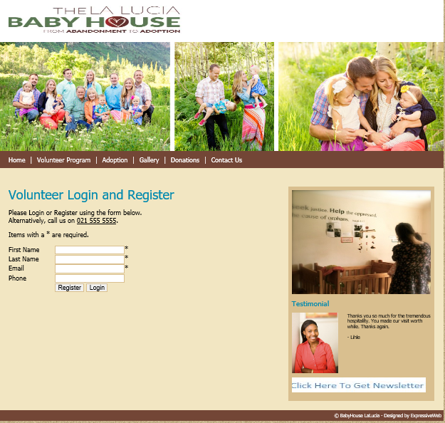

This page of the user will need to Login or Register. A message will display once the user has logged in, Register, or made a mistake.

**Adoption Page:**

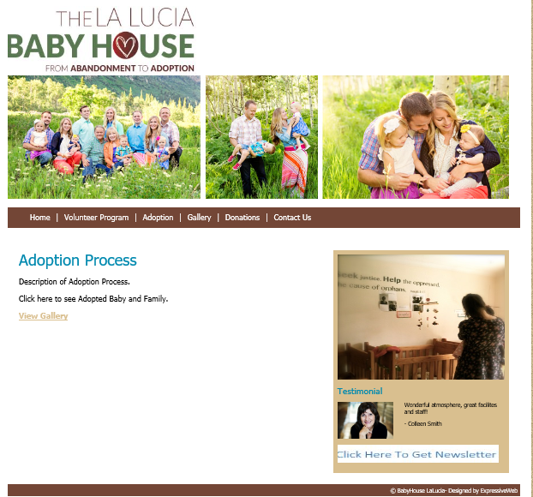

This page will give the user a brief description on how to Adopt a baby from Baby House LaLucia. The user will also be able to click on View Gallery which will show all the babies and families.

**Blog:**

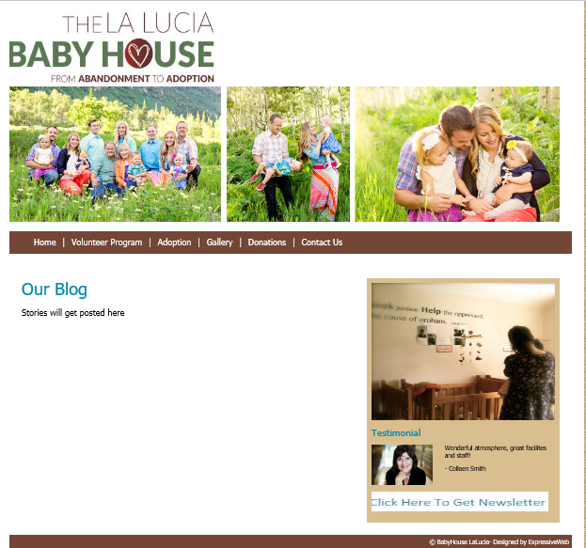

This page will show the user stories about babies and families experiences.

**Donations:**

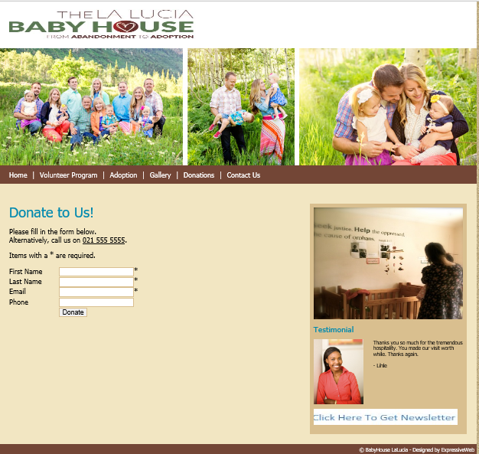

This Page is where the user can donate items to Baby House LaLucia. Once Donated a thank you email will be sent in return.

**Contact Us:**

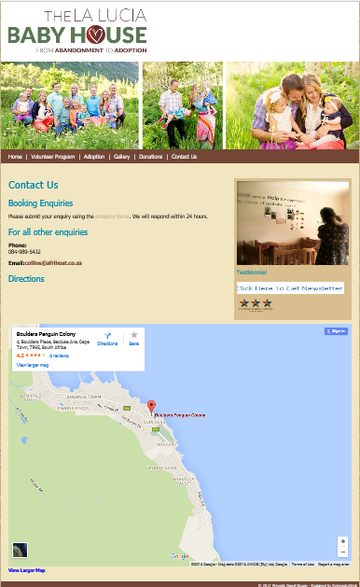

This page will display the Baby House Contact Details and location on Google Maps.